**Project Progress Report**

|  |  |
| --- | --- |
| **Roll Number and Name of the student** |  |
| **Title of the project** |  |
| **Project guide name** |  |

|  |  |  |  |  |
| --- | --- | --- | --- | --- |
| **S. No.** | **From Date** | **To Date** | **Details of project work** | **Project guide sign**  **(with date)** |
|  |  |  |  |  |
|  |  |  |  |  |
|  |  |  |  |  |
|  |  |  |  |  |
|  |  |  |  |  |
|  |  |  |  |  |

|  |  |
| --- | --- |
|  | **Head,** |
|  | **Department of Computer Science** |

**Acknowledgement**

Any attempt at any level cannot be satisfactorily complete without the proper support and guidance of expert people who share their knowledge and experience in order to improve our work. During development of this project we were fortunate to get help, support and encouragement from many people. We would like to acknowledge them for their cooperation.

We are thankful to Prof. Monica Deshmane-Dhotre Ma’am for her support, cooperation, and motivation provided to us during the Study of the project. We also extend our sincere appreciation to her for providing her valuable suggestions and giving us precious time in accomplishing our project report.

We are also thankful to our friends, colleagues, and our instructors for helping with the project.

**Contents**

|  |  |  |
| --- | --- | --- |
| Sr. No. | Title | Page No. |
| 1. | Introduction | 5 |
| 2. | Problem Definition | 6 |
| 3. | Existing system and need for new system | 7 |
| 4. | Scope of proposed system | 8 |
| 5. | Feasibility Study   1. Technical Feasibility 2. Operational Feasibility 3. Economic Feasibility | 9 |
| 6. | Requirement Analysis   1. Software Requirements 2. Hardware Requirements | 11 |
| 7. | Entity Relationship Diagram | 12 |
| 8. | Data Dictionary | 13 |
| 9. | Use Case Diagrams | 15 |
| 10. | Class Diagram | 18 |
| 11. | Sequence Diagrams | 19 |
| 12. | Activity Diagram | 21 |
| 13. | Data-Flow Diagrams | 22 |
| 15. | User Interfaces’ screenshots | 24 |
| 16. | Test Methods | 36 |
| 17. | Limitations | 37 |
| 18. | Future Enhancements | 37 |
| 19 | Conclusion | 38 |
| 20 | Bibliography | 39 |

**Introduction**

India is a developing country and Information Technology is playing important role in development of the country. By ecommerce platform, we mean buying and selling of products over electronic systems such as the Internet.

In India, we are availed multiple ways to pay our bills online or trade online. Additionally, there are numerous online ecommerce platforms for Groceries, Fashion, Food, etc. But we still lack of a dedicated online ecommerce platform for disposable and housekeeping items. Online Retail Shop Management System (ORSMS) fulfills this need of *crores* of business owners who are struggling because of lack of ‘Ease of Doing Business’ in their area of expertise or marketing.

The Indian household cleaners market reached a value of USD 6,163 Million in 2021. Looking forward, it is expected that the market to reach USD 18,757 Million by 2027, exhibiting a CAGR of 19.63% during 2022-2027.

Additionally, India’s disposable food packaging market size reached approximately USD 22.00 Billion in 2022. Looking forward, it is expected that the market to reach 25.65 Billion Units by 2028, exhibiting a growth rate (CAGR) of 2.50% during 2023-2028.

This implies that both markets have reached the valuation of approximately USD 28,163 Million in the years 2021-2022, despite the country was facing serious economic crisis raised due to Covid-19 and nation-wide lockdown. If an industry can make such huge progress without any dedicated, online ecommerce platform, one can imagine its potential, if it is supported by an online platform.

This system allows users to register their details in the system, and allows them to use this system after logging in successfully. This system provides a faster way than the traditional system. This site can be accessed with proper login details.

**Problem Definition**

This is the end of 2022, and it’s been a year since we conquered the covid-19 and the nationwide lockdowns rose because of that unseen villain. But unfortunately, the world is witnessing economic setbacks caused primarily by covid-19 lockdowns and secondarily by the conflict between two major powers, Russia and NATO. These two worst situations continuously raise the possibility of worldwide recession because of high oil prices, high taxes, mass migrations, and major destruction of infrastructure.

India, on the other hand, is continuing its economic growth. India’s GDP growth rate for 2021 was 8.95%, a 15.54% increase from 2020. The share of the IT sector in the GDP of India is 7.4% in FY 2022. The IT industry’s revenue is estimated at USD 227 Billion in FY 2022. It can conclude that India’s market is largely dependent on the IT sector. An information technology industry can boost up any other industry when it is properly synced with IT.

In India, we have online eCommerce platforms for nearly every business/commercial need, being a regular consumer of those services; I should not necessarily explain the importance of syncing an online eCommerce platform with any business.

Considering the damage caused to Indian economic growth because of the pandemic and nationwide lockdown situations, it is necessary for all kinds of local businesses in the country to be synced with an online eCommerce platform, so that the business, its market, its ecosystem, and an overall economy of the nation can play the role of Phoenix.

Online Retail Shop Management System or an ORSMS, a dedicated, online eCommerce platform exclusively made for the B2B as well as B2C transactions of single Housekeeping and Disposable Items Business, can manage the operations of such businesses through a single application, to save time and resources of the business owners and administrators. This platform provides a user-friendly GUI, a robust and secure database management system, and the most secure payment operations.

Seller/s can post their product/s and everyone can buy them at a price mentioned by a seller. This platform will be controlled by a single admin, who is authorized for managing all products and sellers. This feature can also internally regulate the operations performed during the online business.

We can guarantee that this platform will help businesses to save their time and resources to achieve more gains and success.

**Existing System and need for new System**

As we have described in the ‘Problem Definition’ section, for each Indian startup or middle-aged business, there is a need for a dedicated online eCommerce platform to boost their overall performance to get maximum profit.

We should start this from the smaller case or a smaller user of the system, that is a local business owner, who is a retailer, but want to build a network through sellers. It would be beneficial for that business owner as well as the sellers, who will join him/her on this platform.

Currently, business owners owning businesses of housekeeping products and/or disposable items products, have to do business in a typical way, with a lot of paperwork and record maintenance. No business owners can analyze their sales data properly, which leads to a lack of data management aspect in this industry.

This system allows them to keep a track record of the stock available, as well as keep the track record of sellers, who are associated with them. When the product is Out of Stock, the user will get to know the same when they login to the system, in the respective section. This feature can save the time and resources of a seller as well as an admin.

This system provides a facility to classify the products under a specific ‘Category’, which will help track the sales of particular kinds of products so that one can analyze and plan the business strategy accordingly. Additionally, this system provides an Admin Dashboard, where he/she can track sales, and overall statistics of all transactions performed in a system.

**Scope of the Proposed System**

• The proposed system can overcome all the problems and limitations of the current system to run the business of housekeeping and disposable items’ products.

• An admin, a seller, or a customer can operate their respective roles from anywhere and at any time through a laptop or mobile phone, instead of physically going to shops or business centers, or warehouses, which can save resources, time, and effort of everyone involved in this business.

• A customer has the option to make payment using online mode or Cash on Delivery.

• Quick ordering and quick shipping can save the time of an organization, which will eventually lead to the eternal growth of the business.

• Being an online shopping website, the platform will get more exposure through Google AdSense and other digital marketing as well as PR tools.

• A customer can cancel the order at any time.

**Feasibility Study**

Preliminary investigation examines project feasibility, the likelihood the system will be useful to the organization. The main objective of the feasibility study is to test the Technical, Operational and Economical feasibility for adding new modules and debugging old running systems. All systems are feasible if they have unlimited resources and infinite time. There are aspects in the feasibility study portion of the preliminary investigation:

* Technical Feasibility
* Operation Feasibility
* Economic Feasibility

**1. Technical Feasibility**

The technical issue usually raised during the feasibility stage of the investigation includes the following:

* Does the necessary technology exist to do what is suggested?
* Does the proposed equipment have the technical capacity to hold the data required to use the new system?
* Will the proposed system provide adequate response to inquiries, regardless of the number or location of users?
* Can the system be upgraded if developed?
* Are there technical guarantees of accuracy, reliability, ease of access and data security?

Earlier no system existed to cater to the needs of ‘Secure Infrastructure Implementation System’. The current system developed is technically feasible. It is a web based user interface for trade of housekeeping and disposable items products. Thus it provides easy access to the users. The database’s purpose is to create, establish and maintain a workflow among various entities in order to facilitate all concerned users in their various capacities or roles. Permission to the users would be granted based on the roles specified.

Therefore, it provides the technical guarantee of accuracy, reliability and security.

The software and hardware requirements for the development of this project are not many and are already available in-house at any business center or are available as free as open source. The work for the project is done with the current equipment and existing software technology.

Necessary bandwidth exists for providing fast feedback to the users irrespective of the number of users using the system.

**2. Operational Feasibility**

Proposed project is beneficial only if it can be turned into an information system. That will meet the organization’s operating requirements. Operational feasibility aspects of the project are to be taken as an important part of the project implementation. Some of the important issues raised are to test the operational feasibility of a project includes the following: -

* Is there sufficient support for the management from the users?
* Will the system be used and work properly if it is being developed and implemented?
* Will there be any resistance from the user that will undermine the possible application benefits?

This system is targeted to be in accordance with the above-mentioned issues. Beforehand, the management issues and user requirements have been taken into consideration. So there is no question of resistance from the users that can undermine the possible application benefits.

The well-planned design would ensure the optimal utilization of the computer resources and would help in the improvement of performance status.

**3. Economic Feasibility**

A system can be developed technically and that will be used if installed must still be a good investment for the organization. In the economic feasibility, the development cost

in creating the system is evaluated against the ultimate benefit derived from the new systems. Financial benefits must equal or exceed the costs.

The system is economically feasible. It does not require any additional hardware or paid software. Since the interface for this system is developed using the existing resources and technologies available at any business infrastructure, there is nominal expenditure and economic feasibility for certain.

**Requirement Analysis**

Requirement analysis produces in the specification of software operational characteristics:

It indicates software interface with other system elements. It establishes constraints that should be accomplished.

* Requirement analysis provides information, function & behavior that can be translated into architectural interface & component level design.
* This translation is performed during construction of an analysis model.
* It includes:
* Decision and addition of all important functions which are maintained in the requirements.
* Decision and addition of all important functions which are not maintained in the requirements, but it is essential to build.
* Definitions of all interfaces of the software to be developed
* **Software Requirements:**

|  |  |
| --- | --- |
| Operating System/s: | Windows/Linux |
| Browsers: | Mozilla Firefox, Google Chrome |
| Front-end: | ReactJS, HTML/CSS, JavaScript, Bootstrap |
| Back-end: | MongoDB |
| Platform: | NodeJS |

* **Hardware Requirements:**

|  |  |
| --- | --- |
| Processor: | Pentium III or any advanced processor |
| RAM: | 256MB or more |
| Hard Disk Space: | 40GB or more |

**Entity-Relationship Diagram**

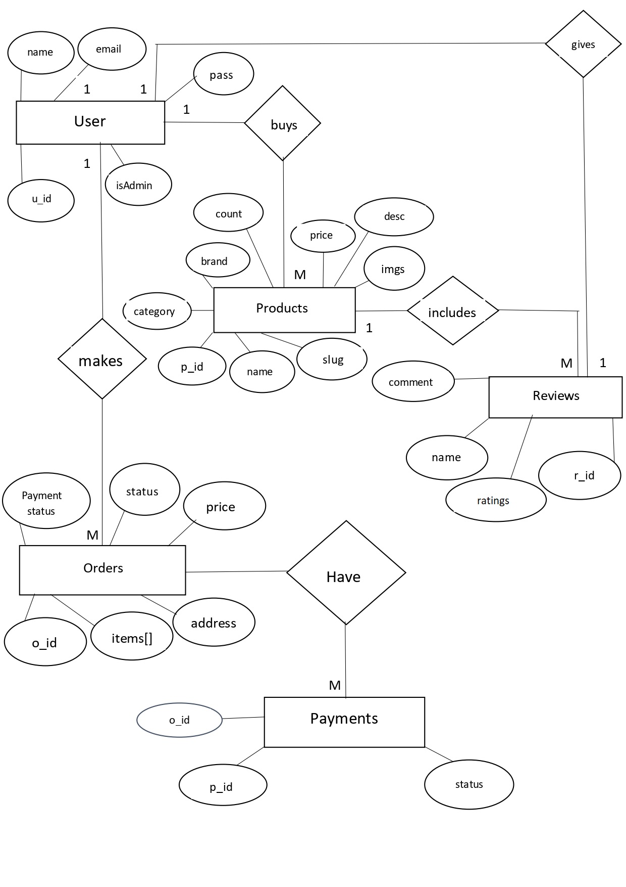

**Data Dictionary**

*Collection Name: orders*

|  |  |  |
| --- | --- | --- |
| **Field Type** | **DataType** | **Description** |
| _id | object | Unique, pk auto-generated by mongo |
| orderItems | array | required |
| shippingAddress | object | required |
| paymentMethod | string | required |
| itemsPrice | number | required |
| shippingPrice | number | required |
| taxPrice | number | required |
| totalPrice | number | required |
| user | object | required, fk of user collection |
| isPaid | boolean | Payment status |
| isDelivered | boolean | Delivery status |
| createdAt | date | Timestamp generated by mongo |
| updatedAt | date | Timestamp generated by mongo |
| paidAt | date | Payment Timestamp |
| deliveredAt | date | Delivery Timestamp |
| paymentResult | string | Payment status (success or failure) |

*Collection Name: products*

|  |  |  |
| --- | --- | --- |
| **Field Type** | **DataType** | **Description** |
| _id | object | Unique, pk auto-generated by mongo |
| name | string | required, unique |
| slug | string | required, unique |
| image | string | required |
| images | string | required |
| brand | string | required |
| category | string | required |
| description | string | required |
| price | number | required |
| countInStock | number | required |
| rating | number | required |
| numReviews | number | required |
| reviews | object | required |
| createdAt | date | Timestamp generated by mongo |
| updatedAt | date | Timestamp generated by mongo |

*Collection Name: reviews*

|  |  |  |
| --- | --- | --- |
| **Field Type** | **DataType** | **Description** |
| _id | object | Unique, pk auto-generated by mongo |
| name | string | required |
| comment | string | required |
| rating | string | required |
| createdAt | date | Timestamp generated by mongo |
| updatedAt | date | Timestamp generated by mongo |

*Collection Name: users*

|  |  |  |
| --- | --- | --- |
| **Field Type** | **DataType** | **Description** |
| _id | object | Unique, pk auto-generated by mongo |
| name | string | required |
| email | string | required |
| password | string | required, stored using JWT tokens for security purposes |
| isAdmin | boolean | required |
| createdAt | date | Timestamp generated by mongo |
| updatedAt | date | Timestamp generated by mongo |

*Collection Name: payments*

|  |  |  |
| --- | --- | --- |
| **Field Type** | **DataType** | **Description** |
| _id | object | Unique, pk auto-generated by mongo |
| order_id | string | required |
| name | string | required |
| status | string | required |
| createdAt | date | Timestamp generated by mongo |
| updatedAt | date | Timestamp generated by mongo |

**Use-Case Diagrams**

**Use Case 1:**

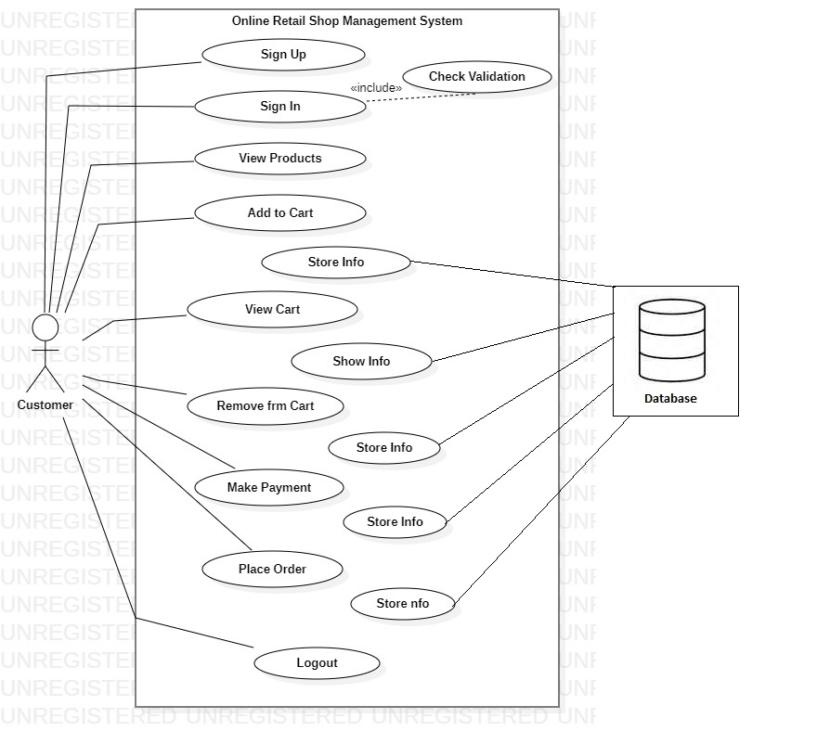

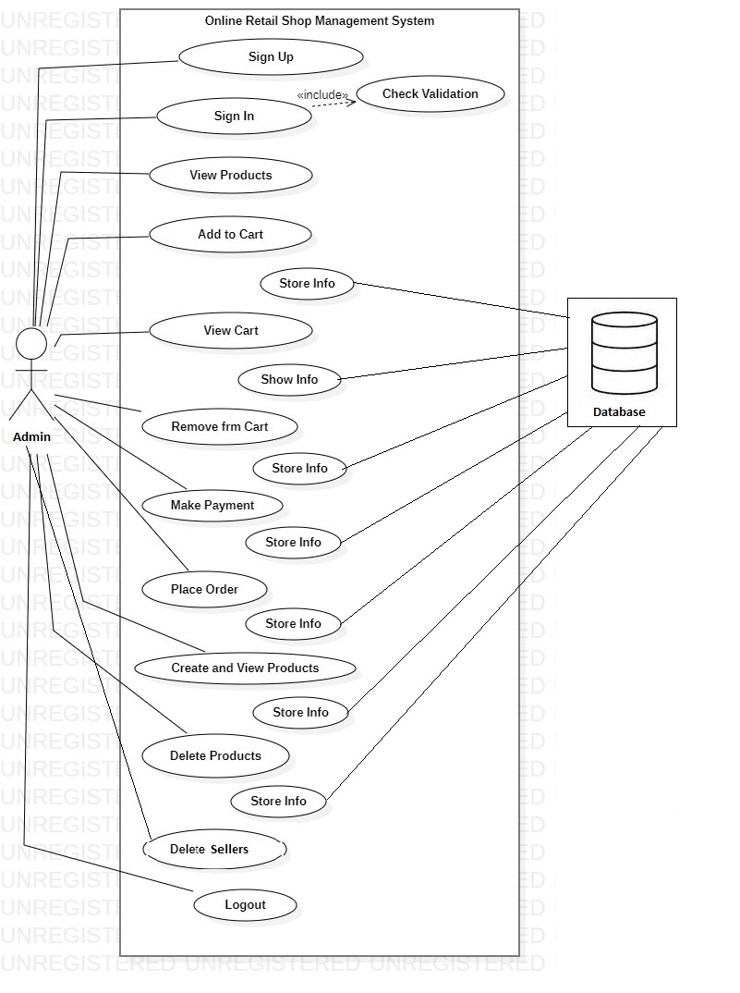

**Use Case 2:**

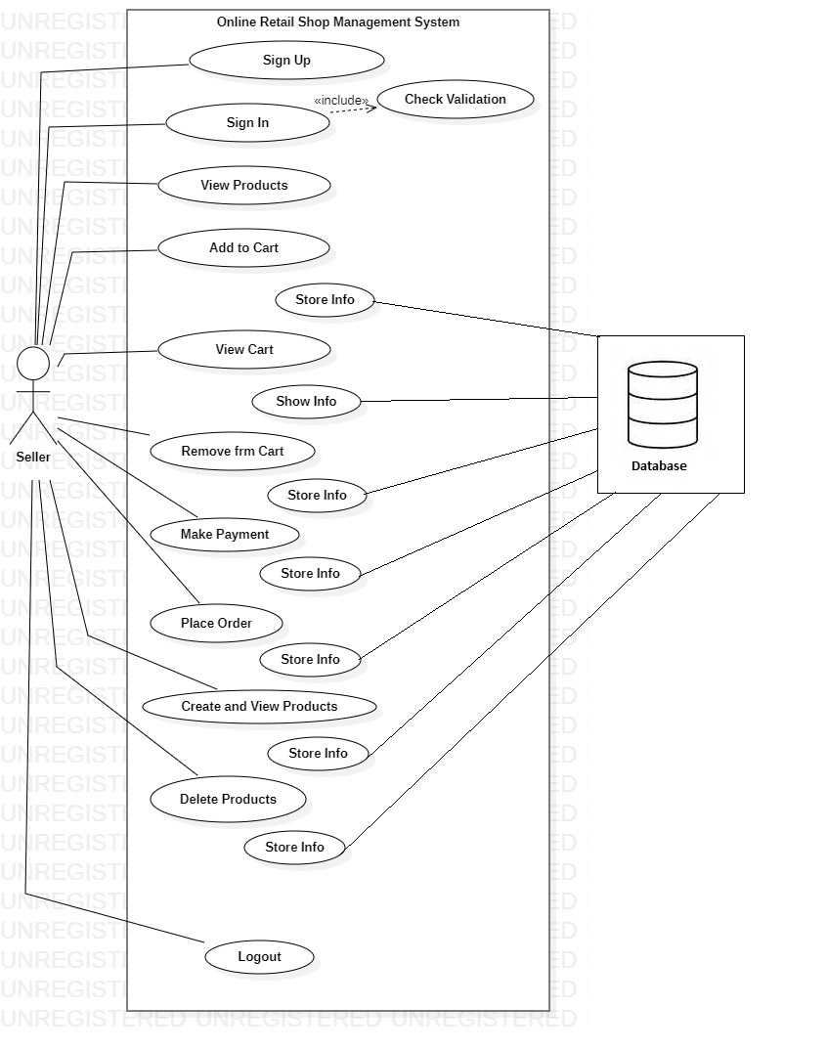

**Use Case 3:**

**Class Diagram**

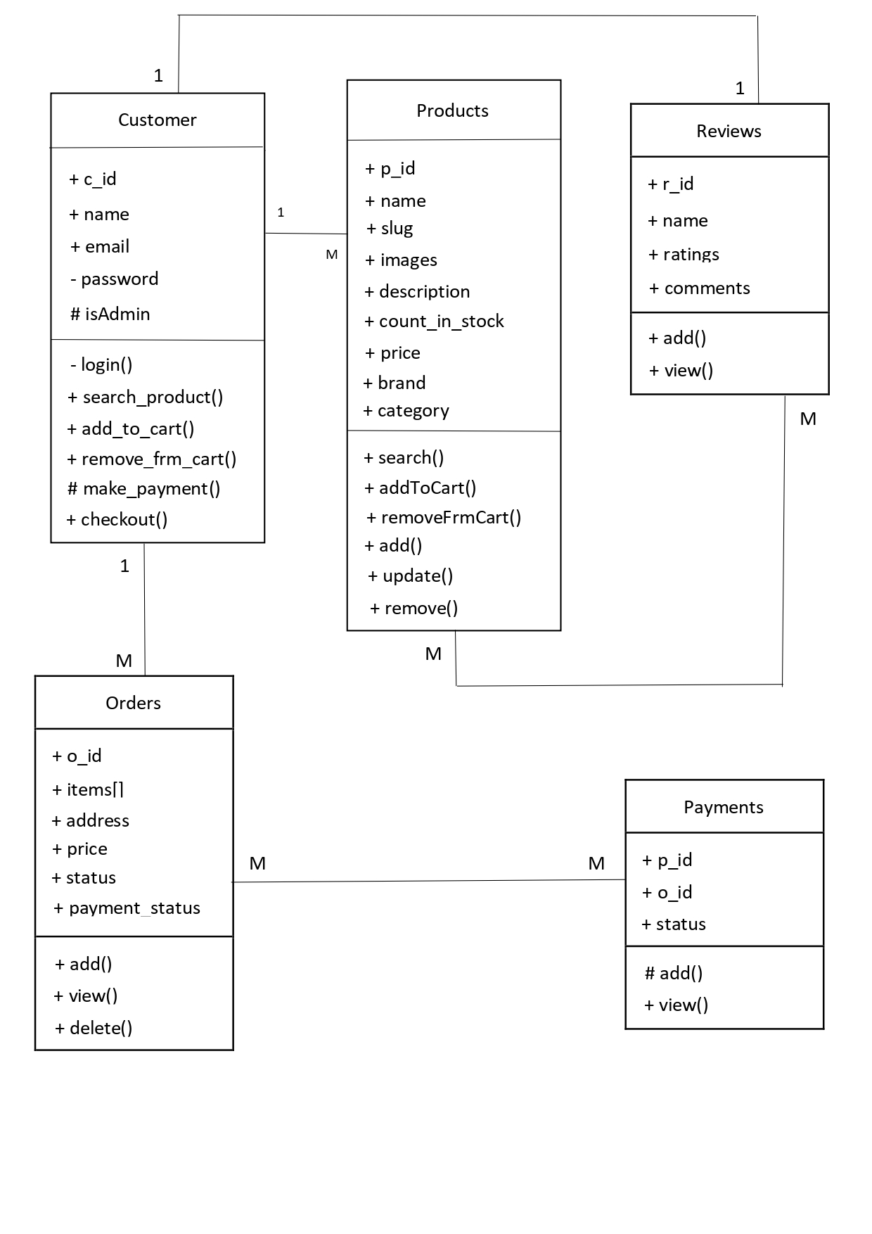

**Sequence Diagram**

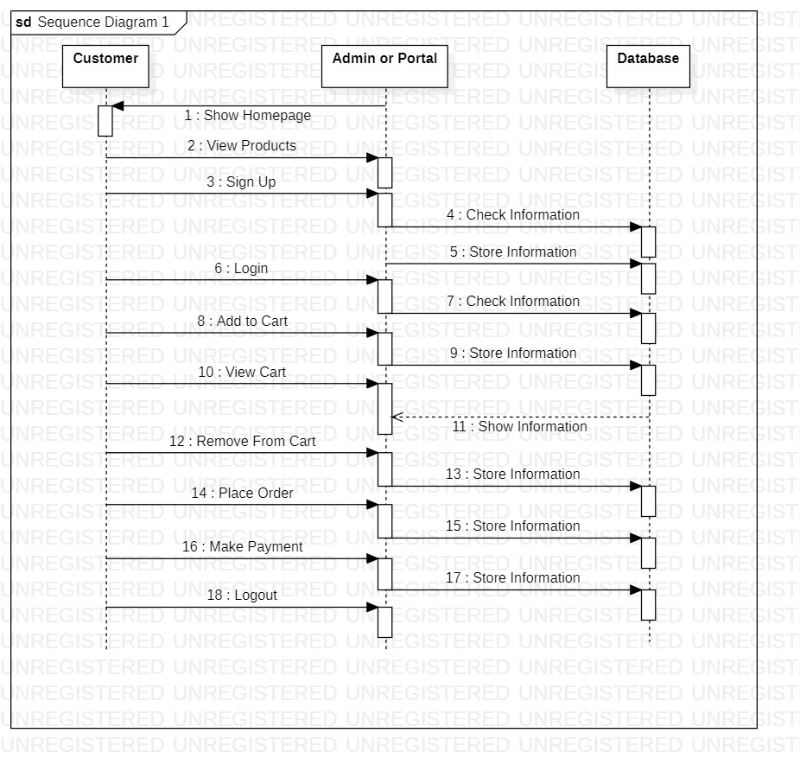

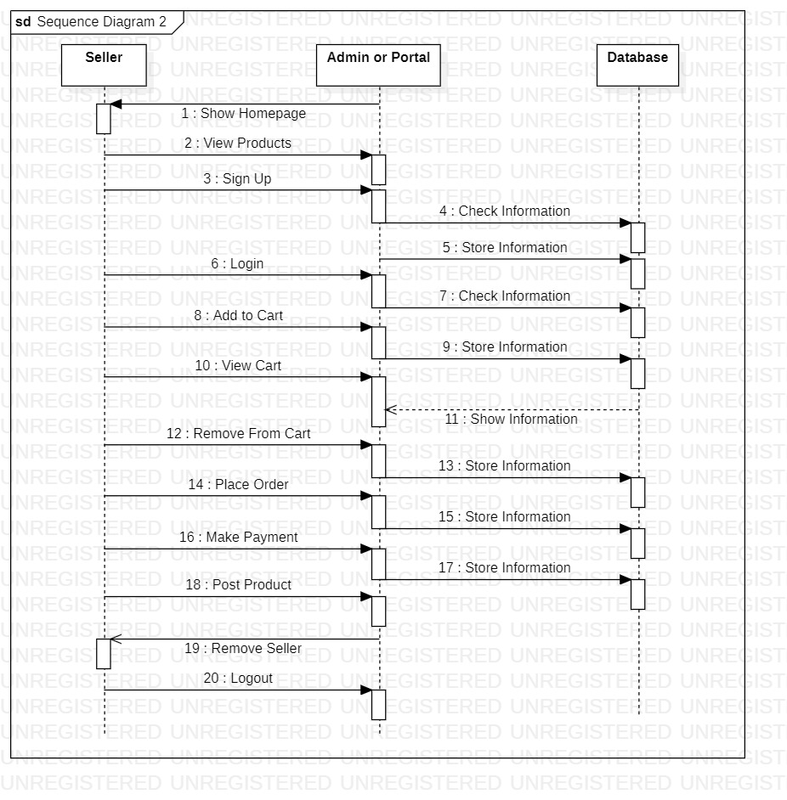

**Activity Diagram**

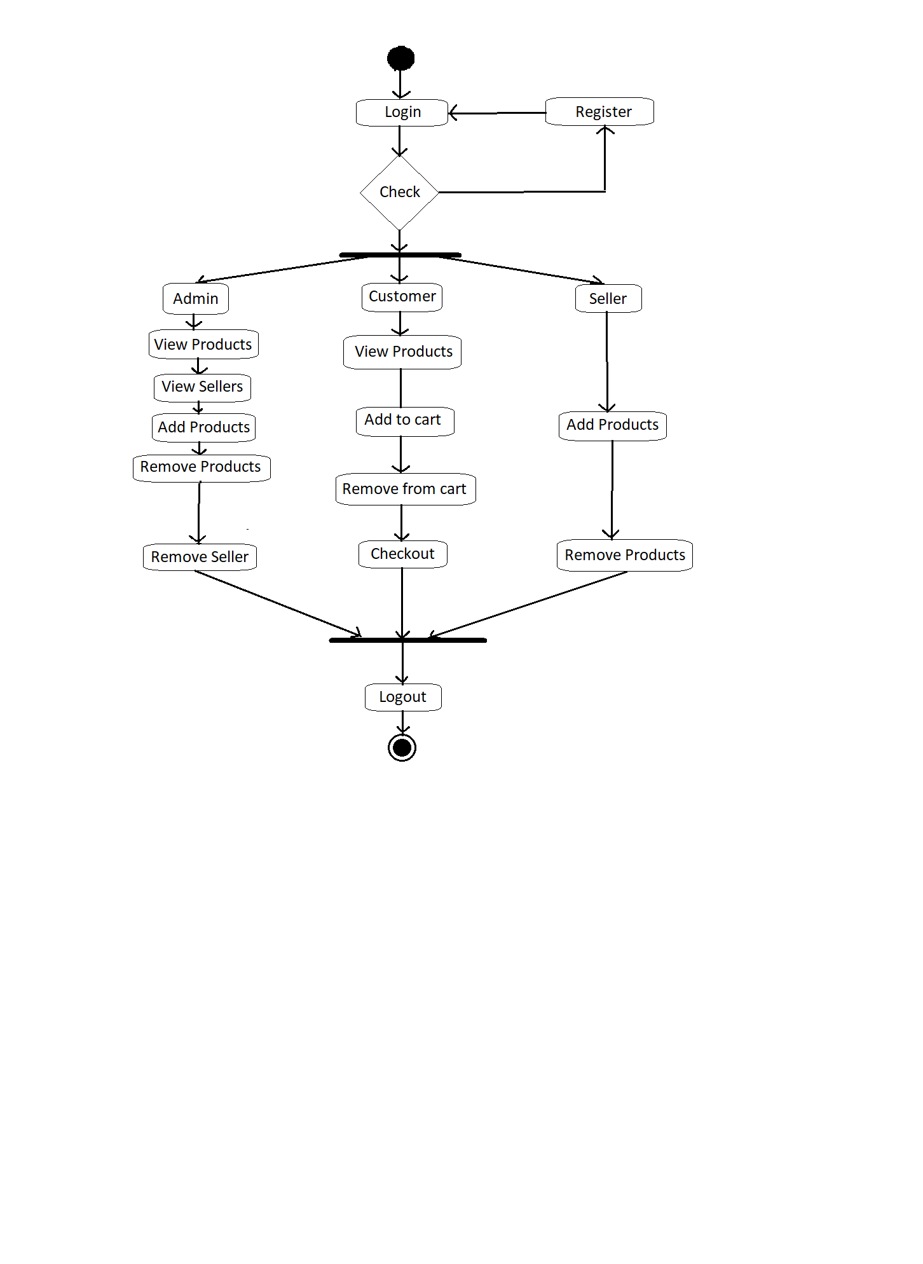

**Data-Flow Diagrams**

**DFD Level 0:**

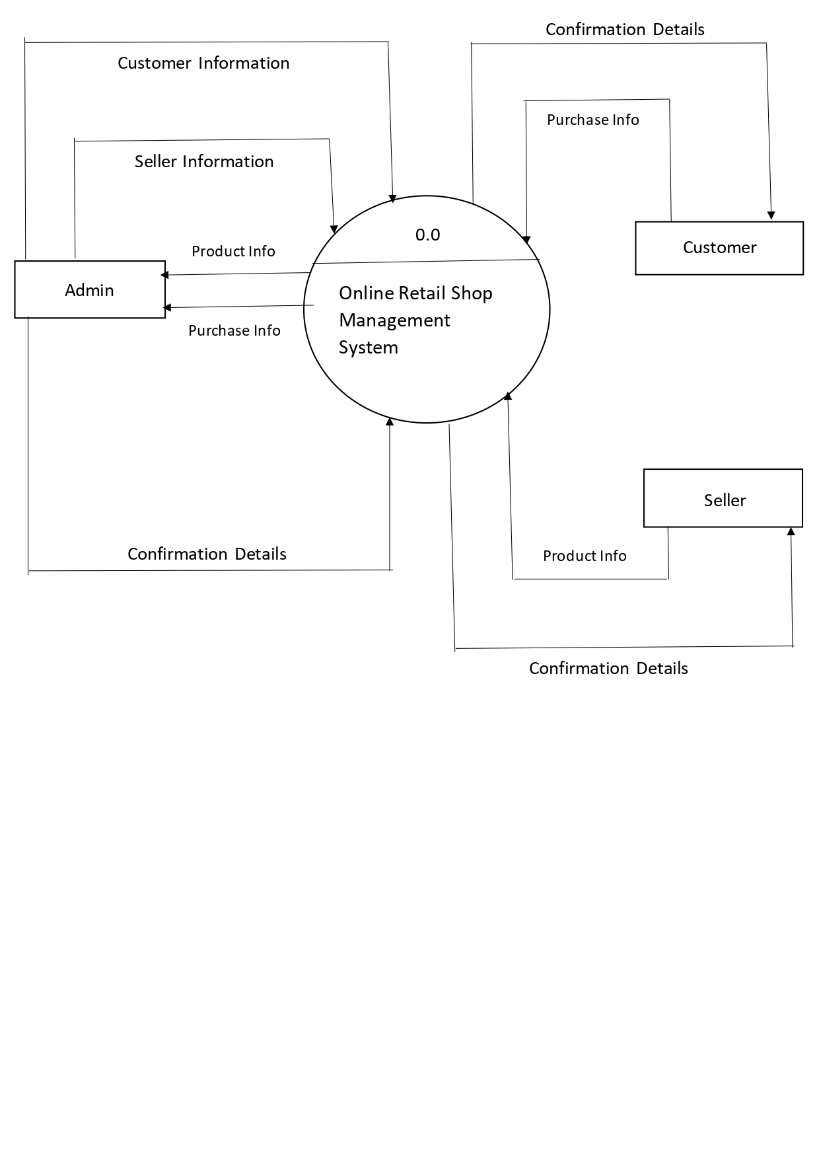

**DFD Level 1:**

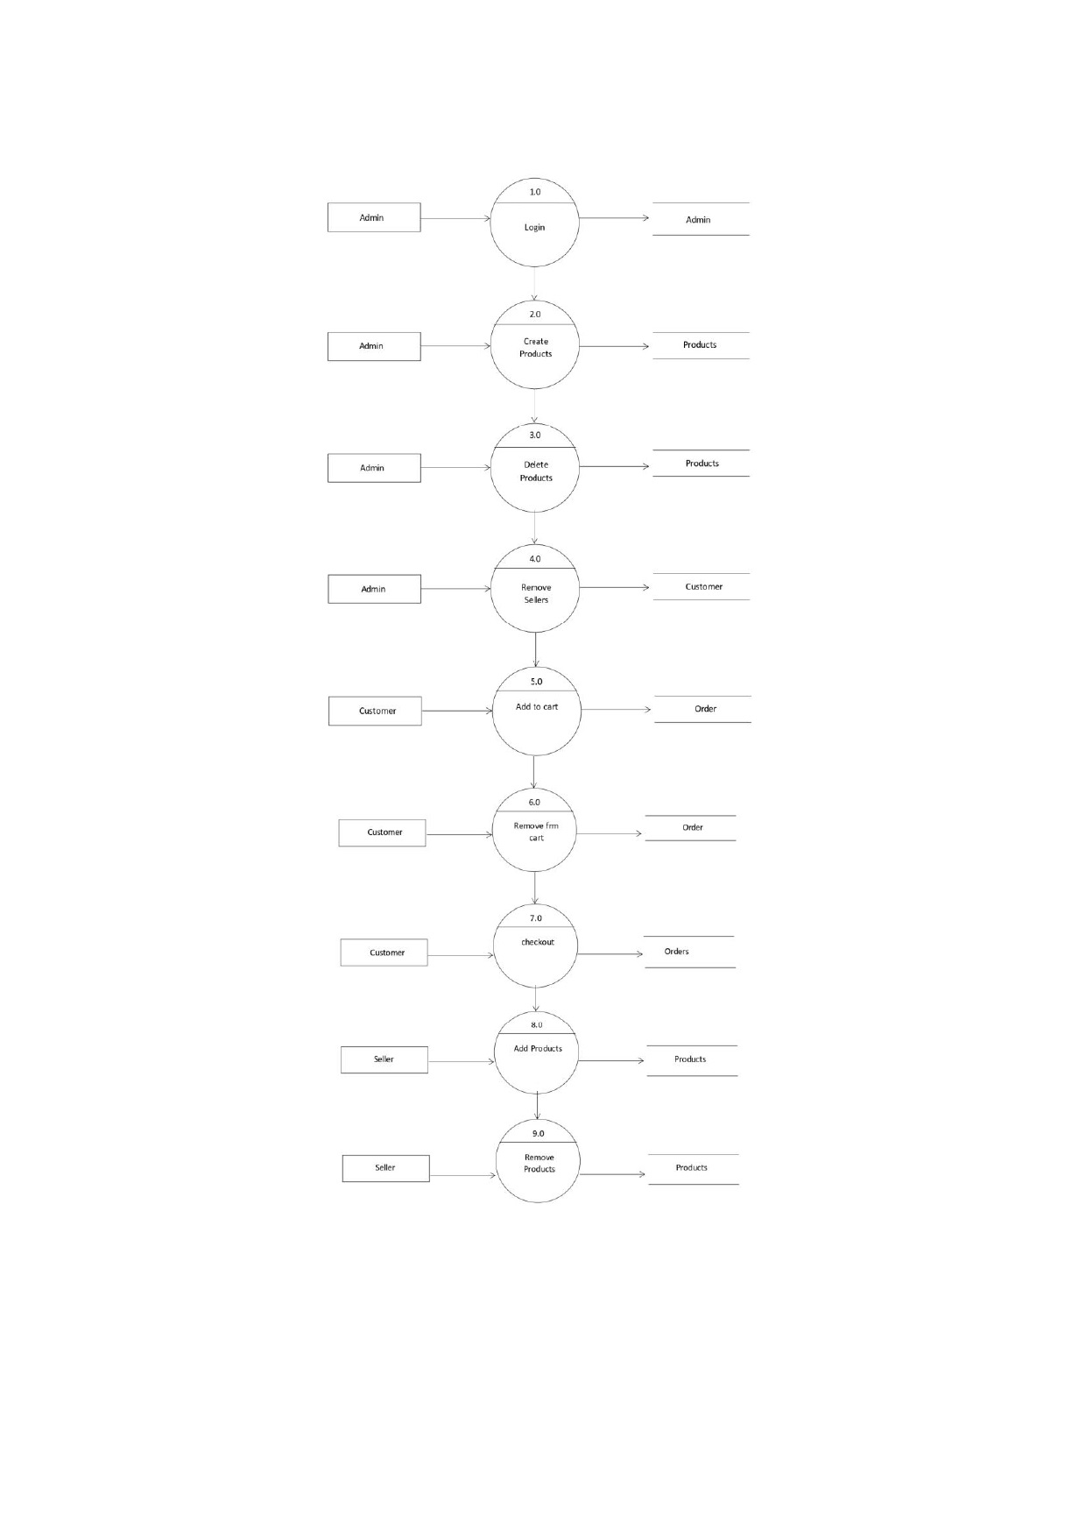

**User Interfaces**

**1. Home Page:**

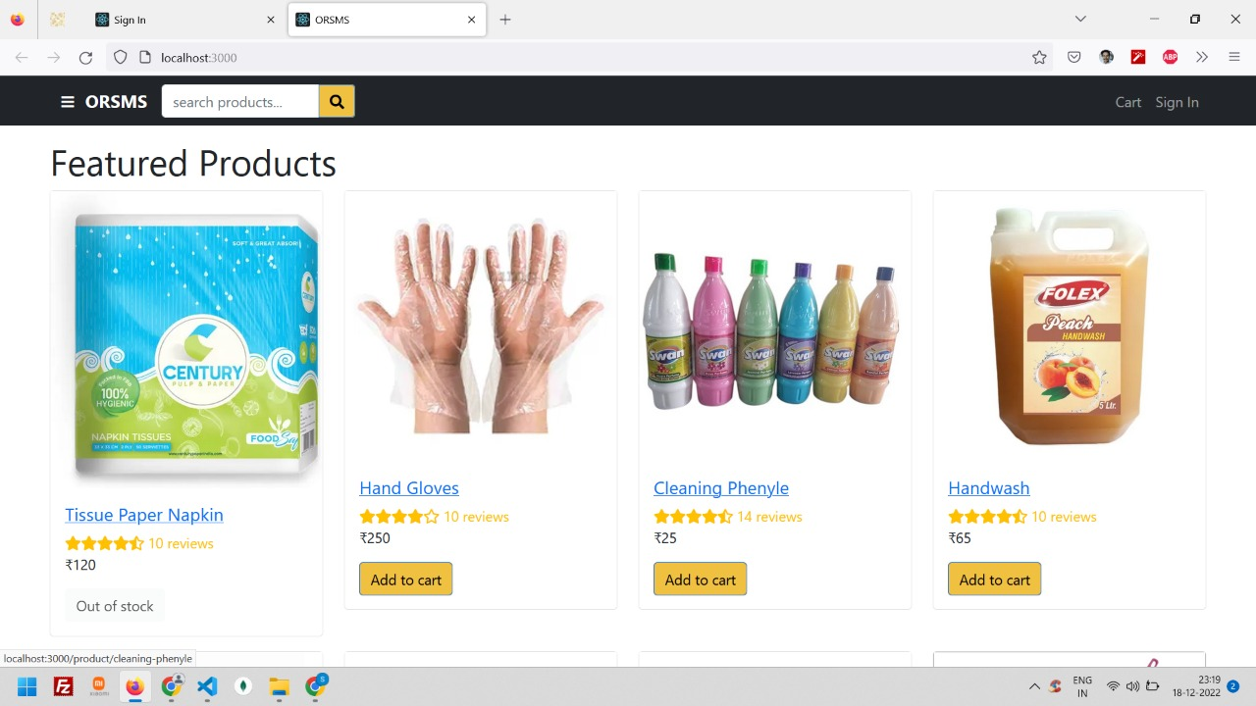

**2. Sign In Page:**

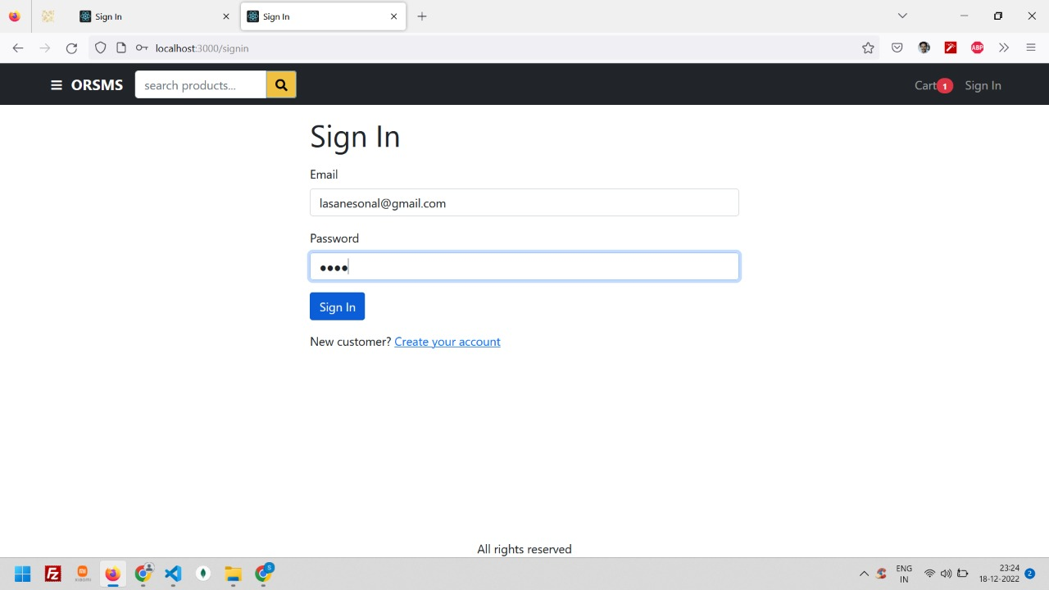

**3. Sign Up Page:**

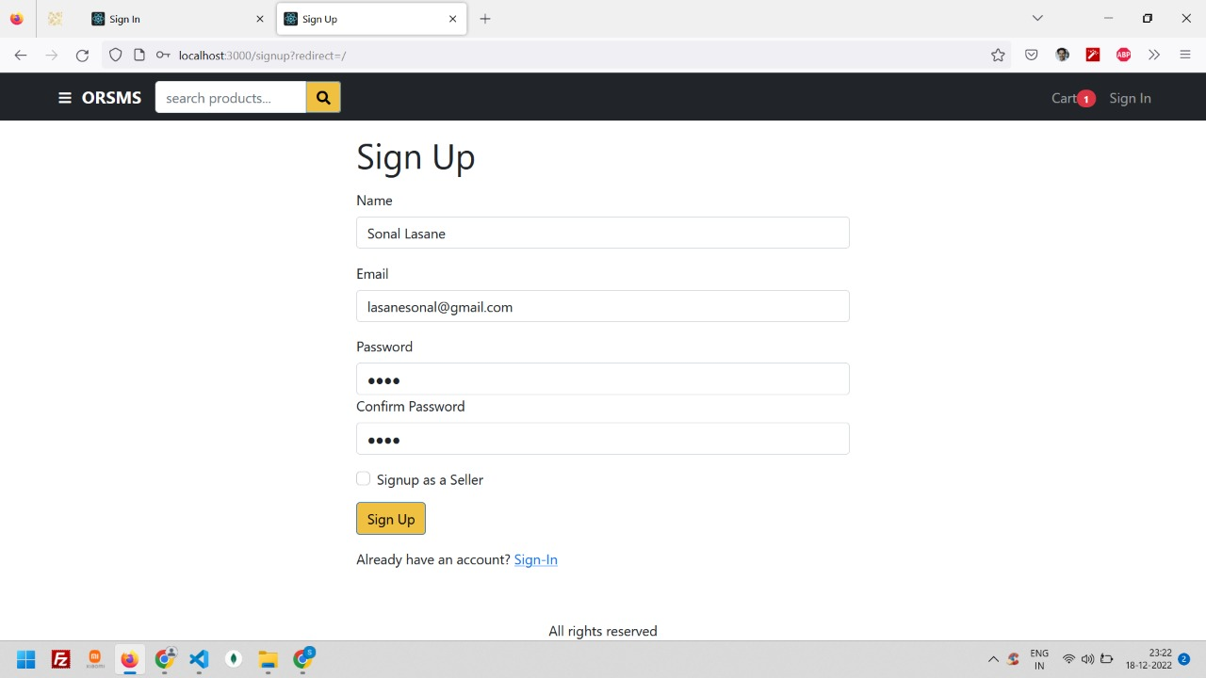

**4. Customer Login:**

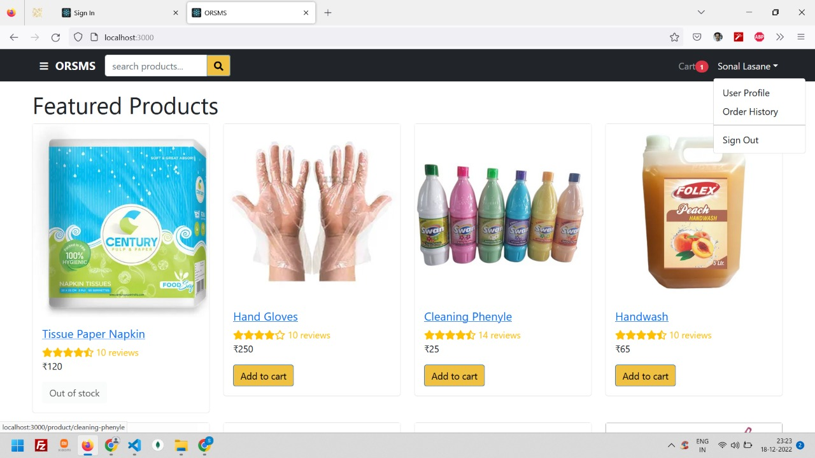

**5. Seller Login:**

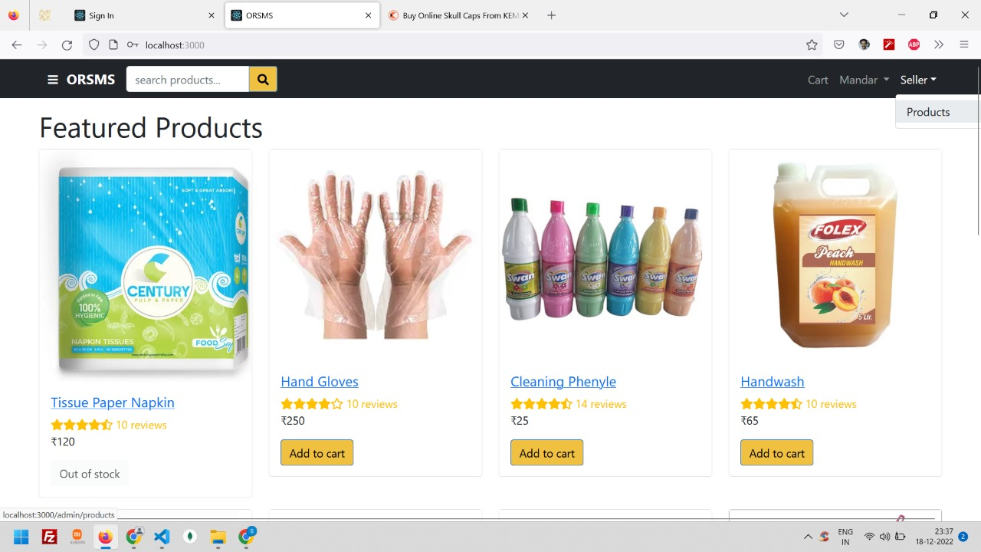

**6. Admin Login:**

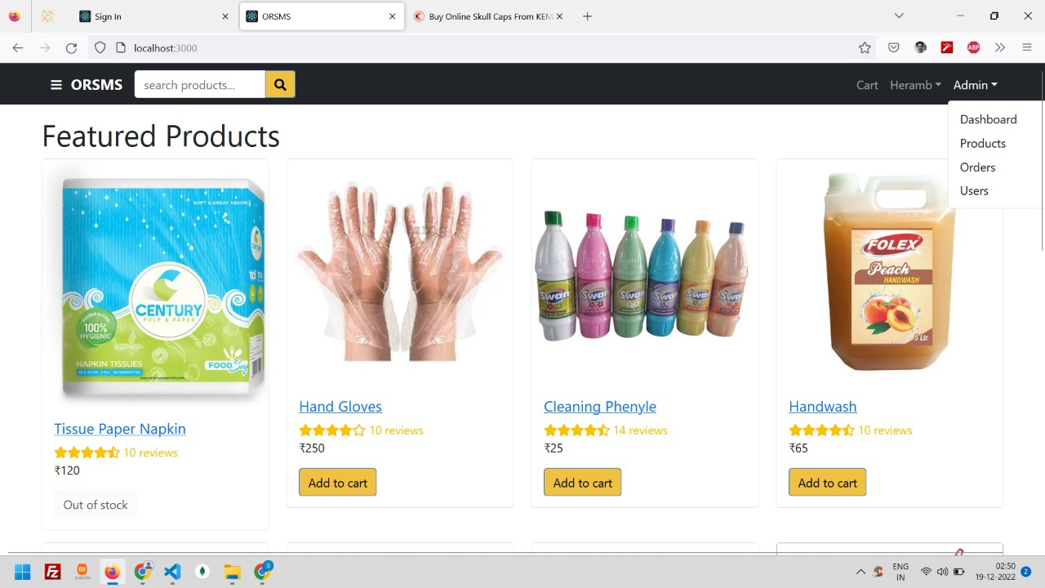

**7. Product Details:**

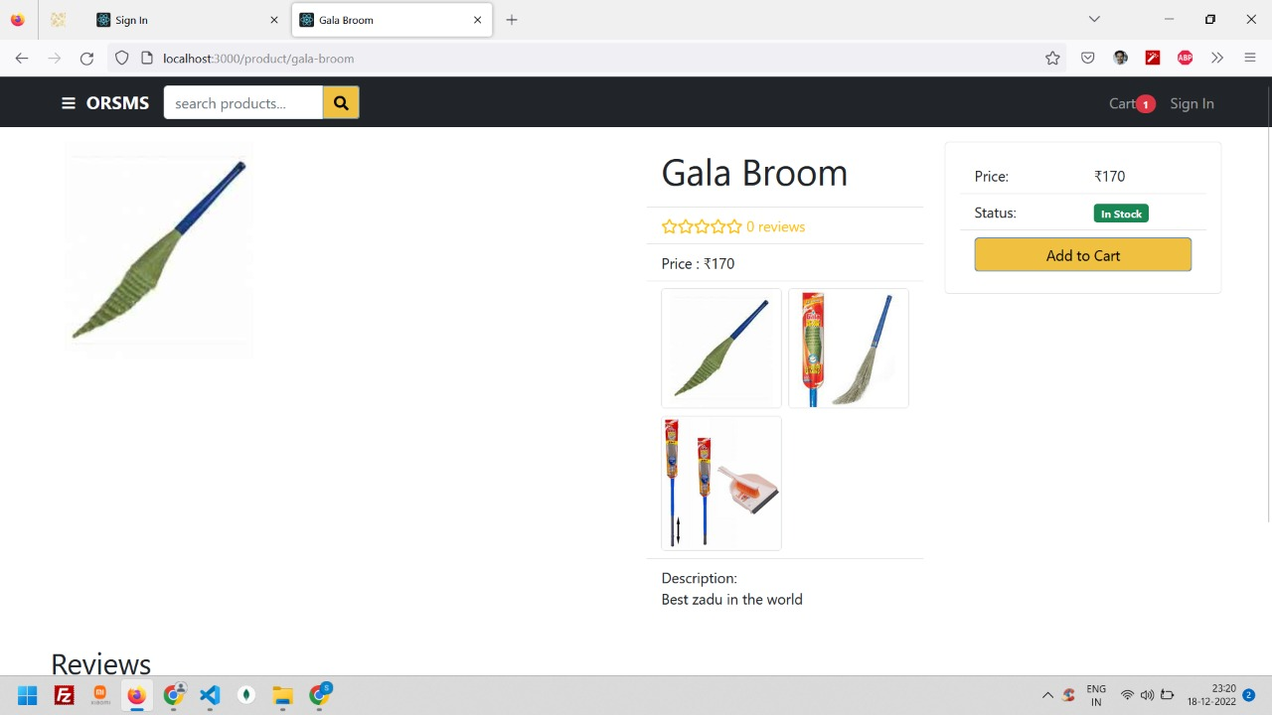

**9. Shipping Page:**

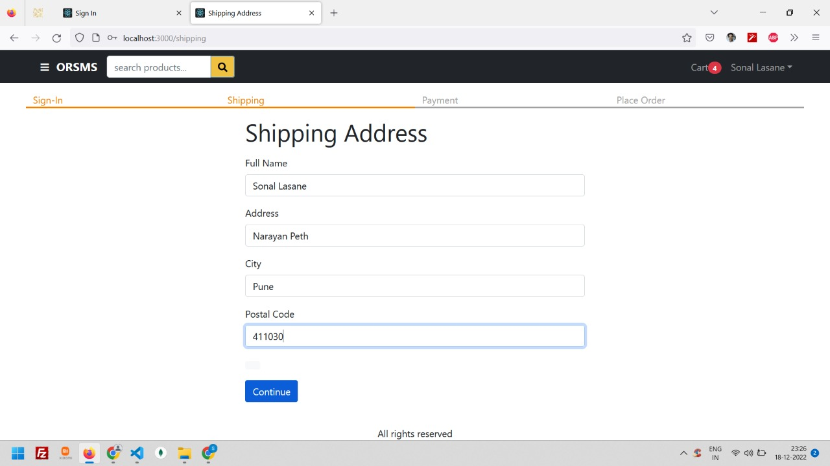

**10. Order Confirmation Page:**

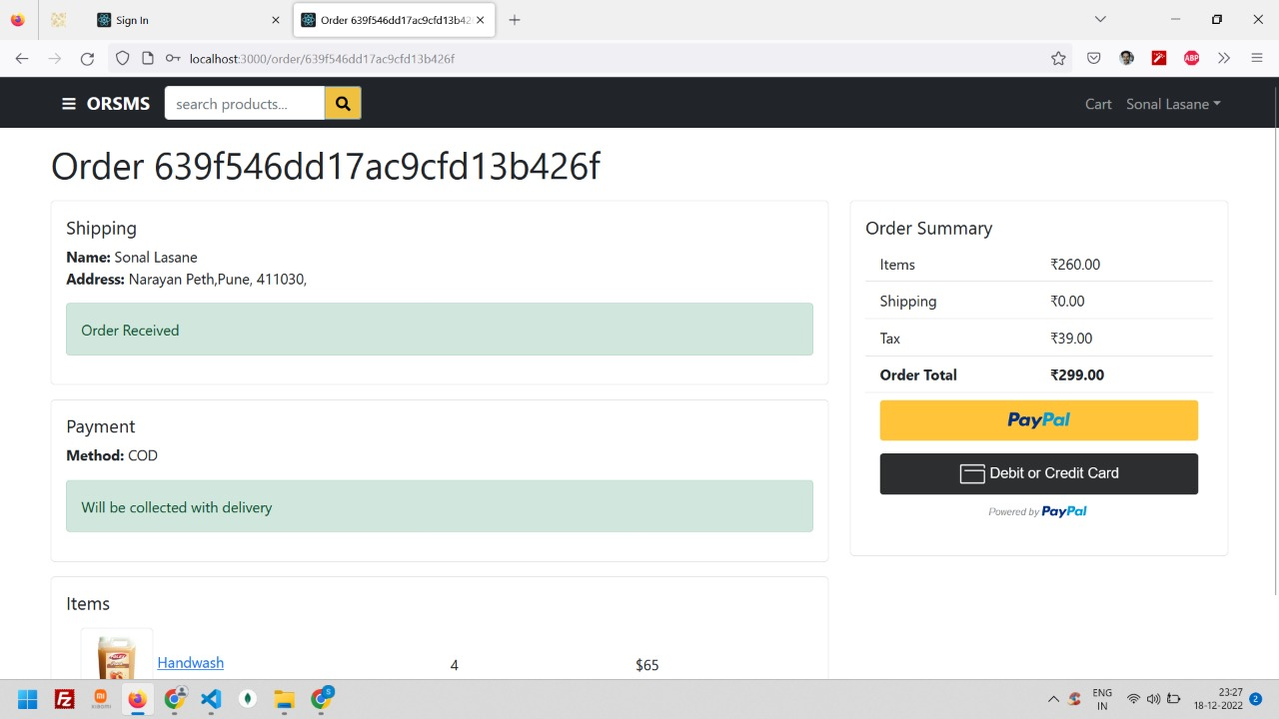

**11. Order Details Page:**

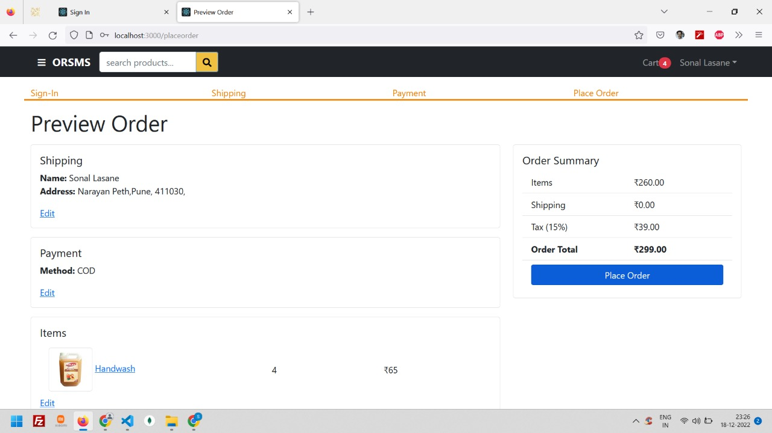

**12. Order History Page:**

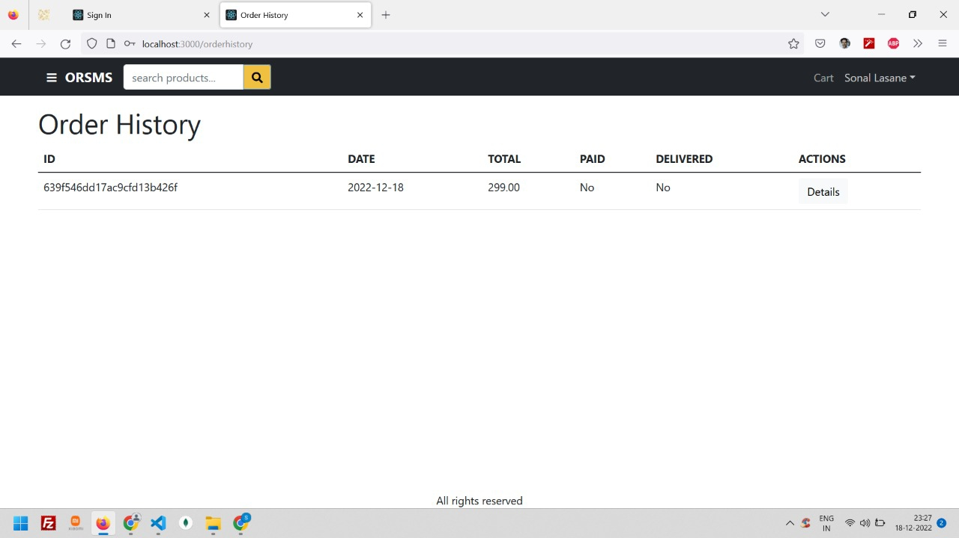

**13. Search or Filter Products:**

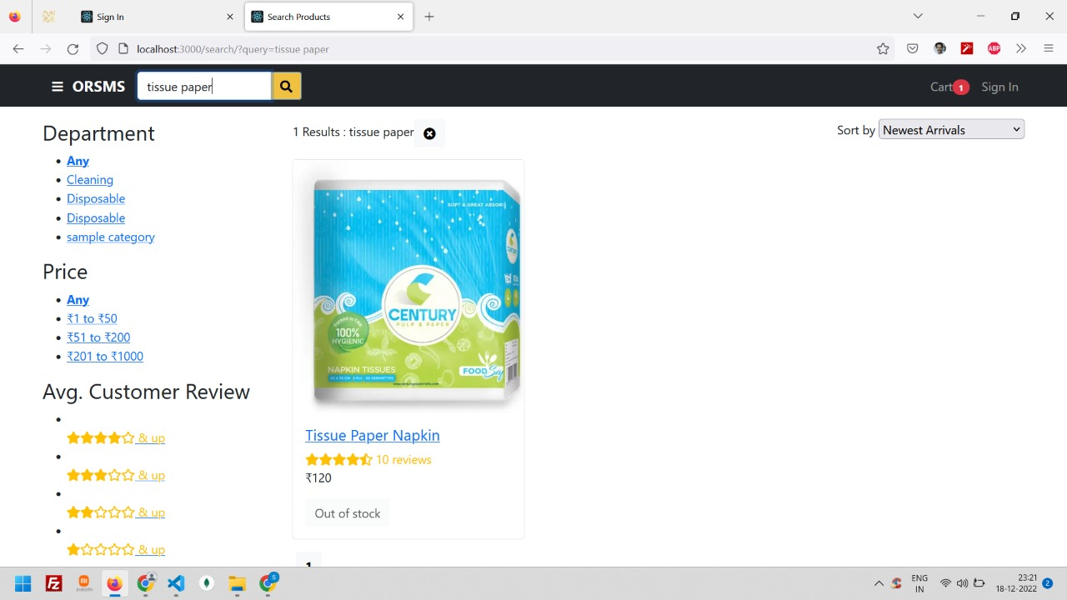

**14. Cart Page:**

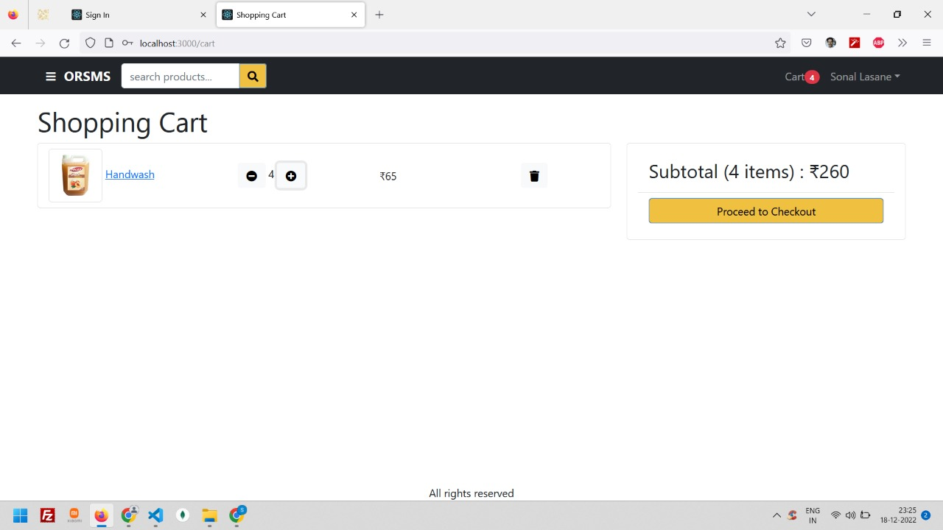

**15. Cart Page Dynamically Add Products:**

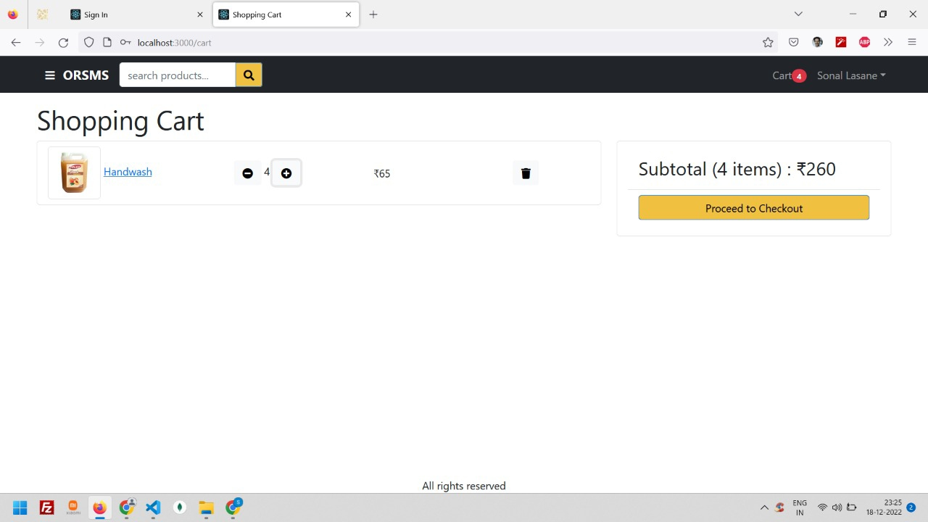

**16. Create Product:**

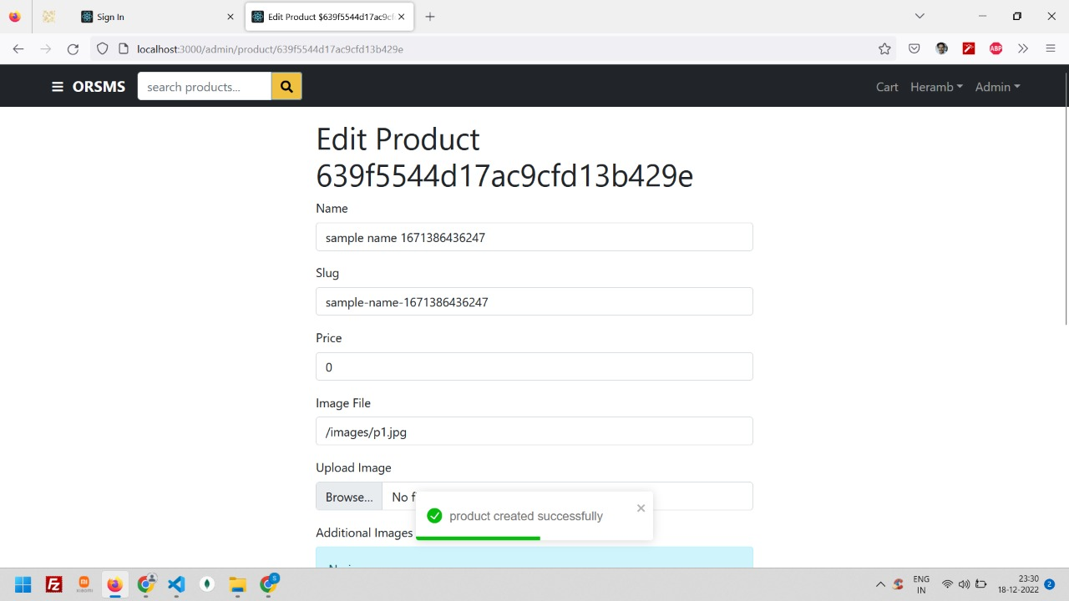

**17. Edit Product:**

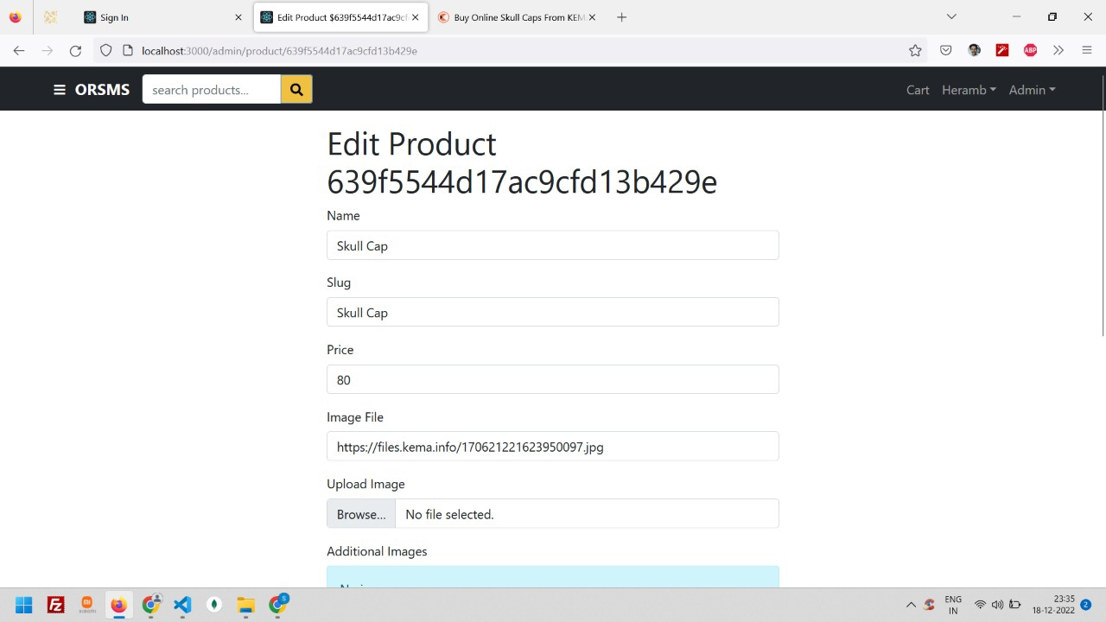

**18. Order List Page – Admin Login:**

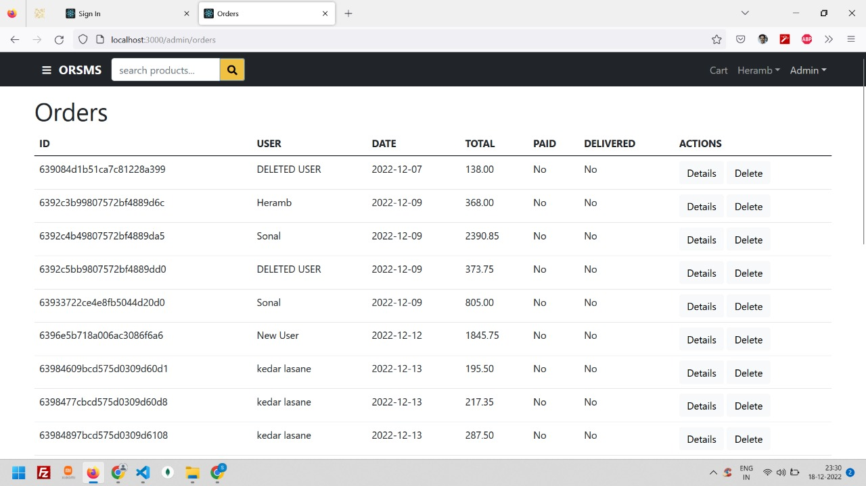

**19. Users List Page – Admin Login:**

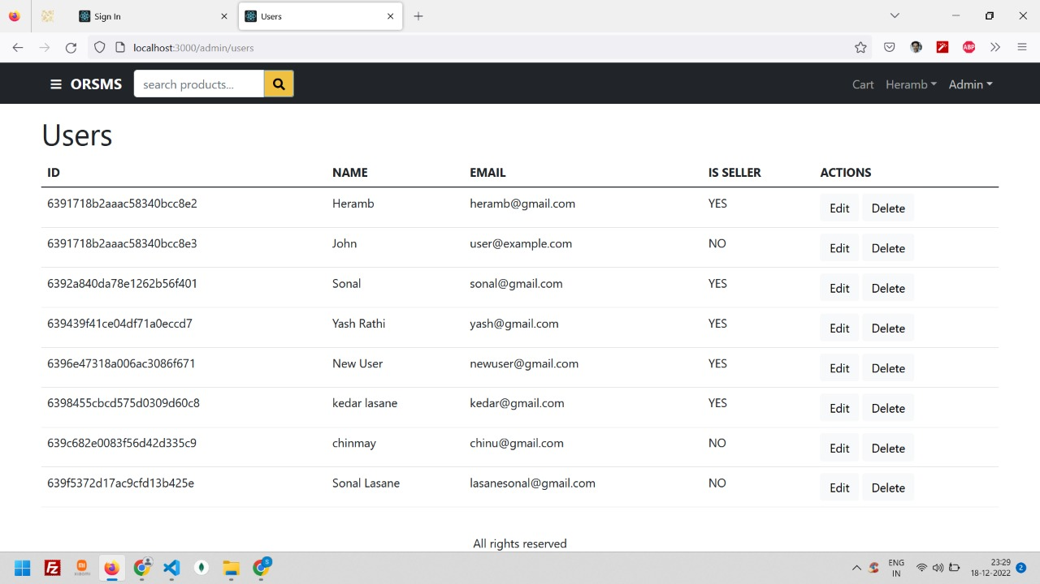

**20. Product List - Admin Login:**

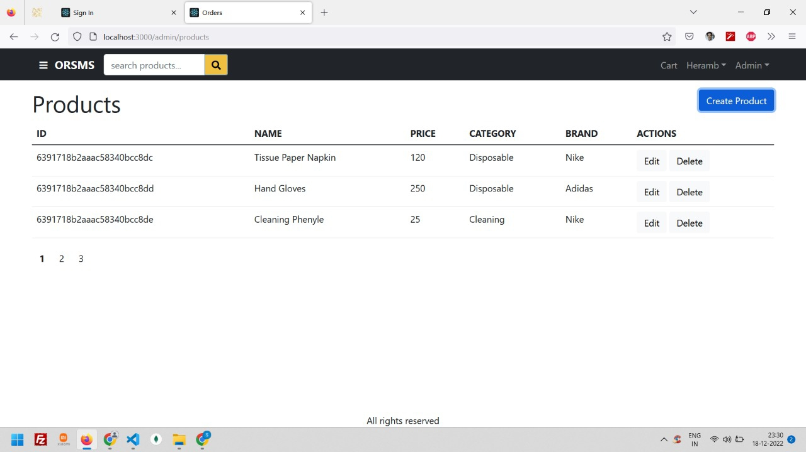

**21. Admin Dashboard 1 For Sales – Admin Login:**

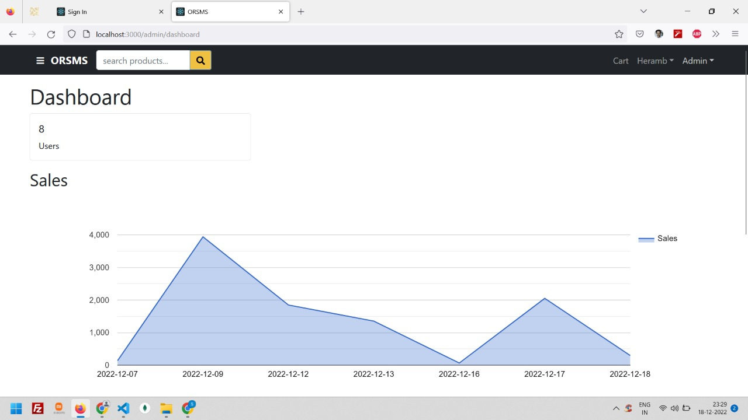

**22. Admin Dashboard 2 For Product Categories – Admin Login:**

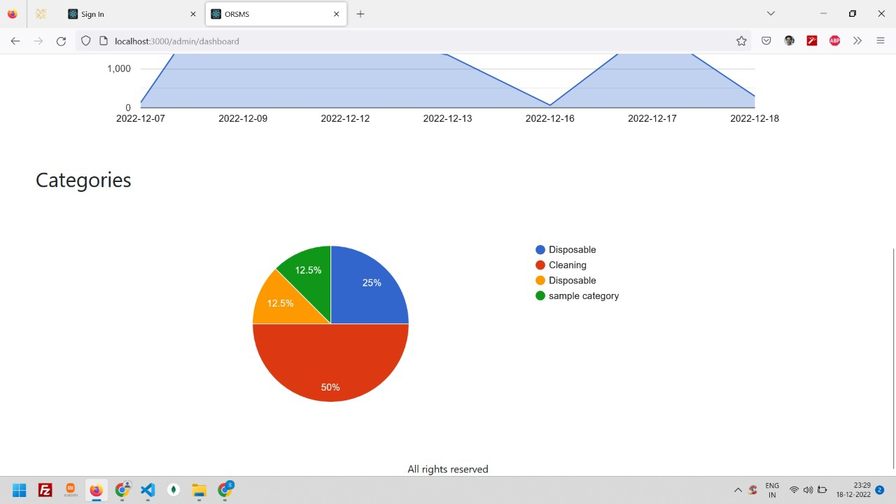

**23. Google Map to Choose delivery location:**

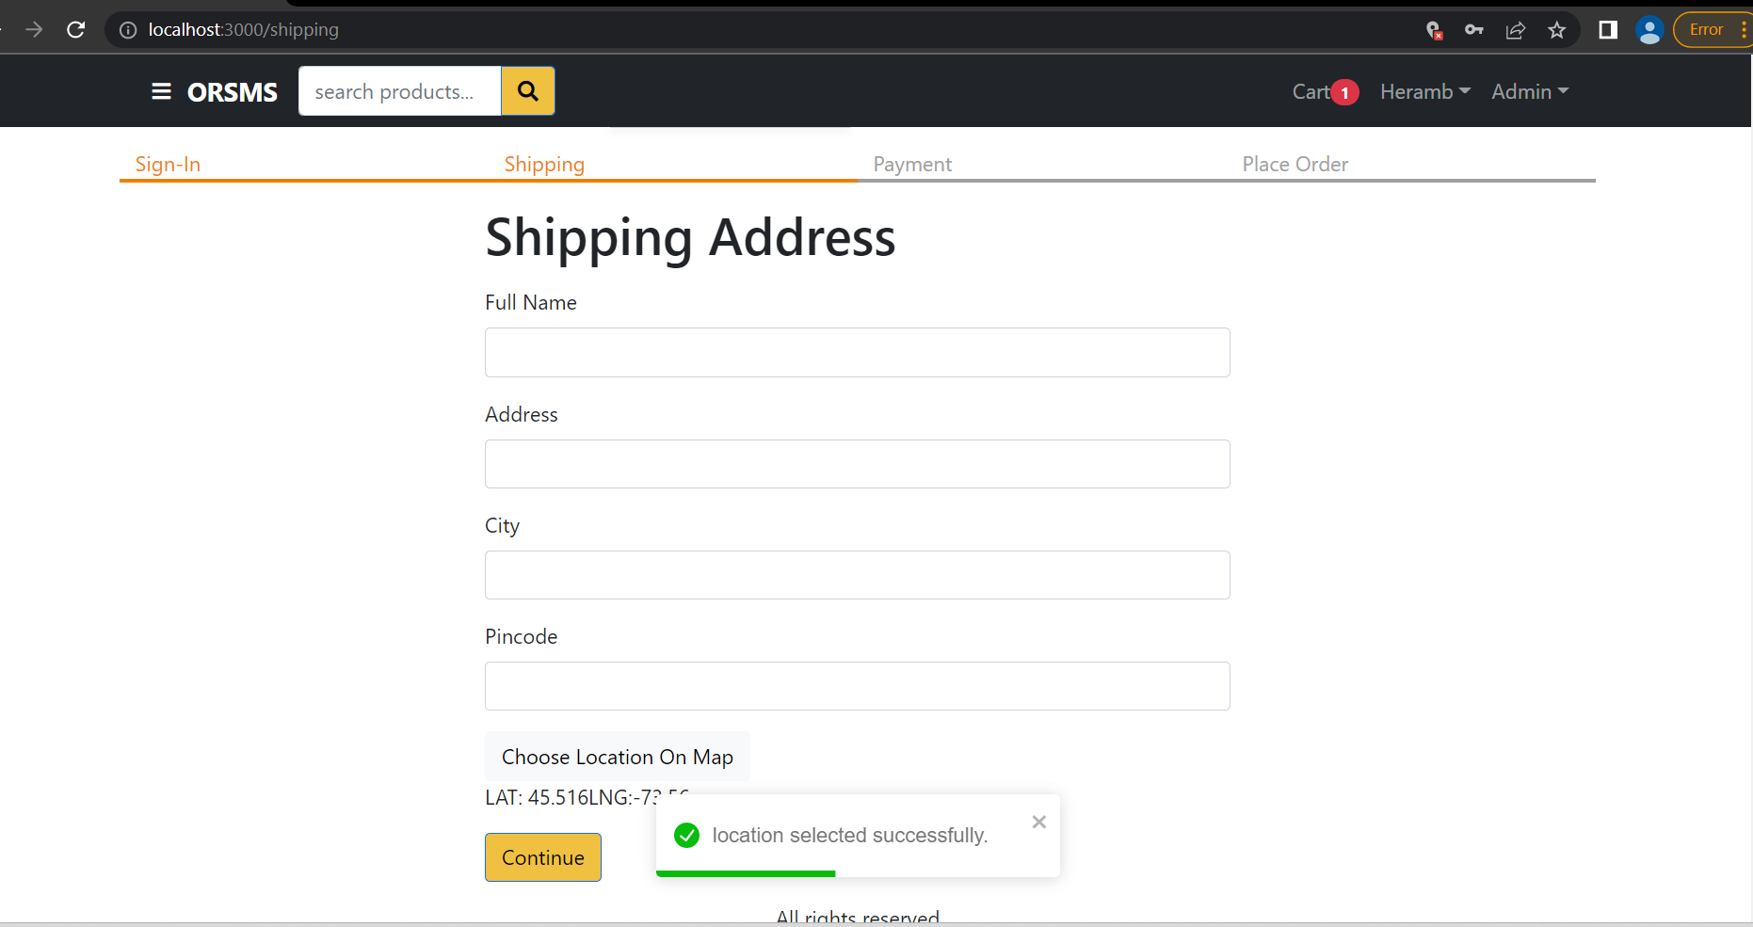

**24. Location Selection in Google Maps**

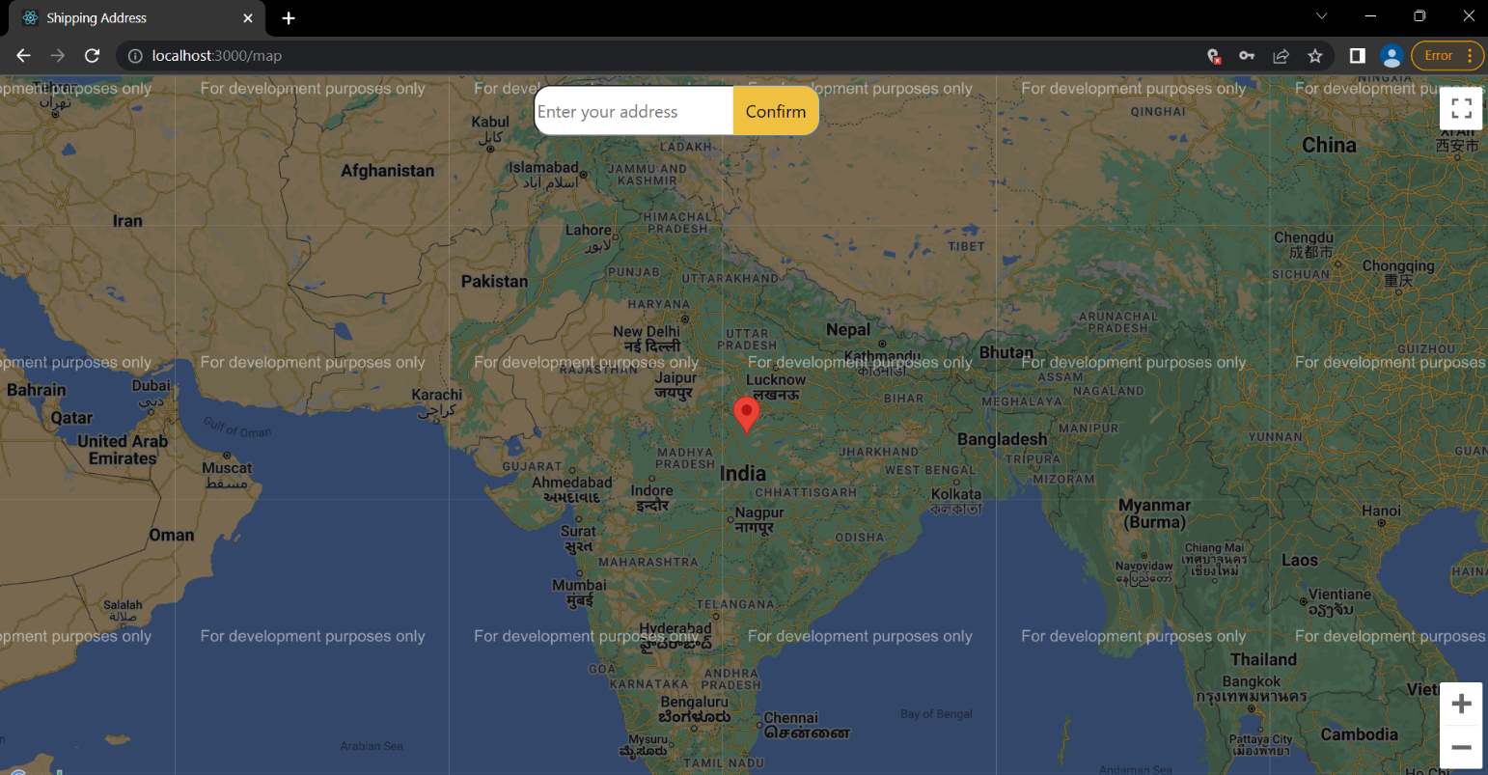

**Testing Methods Used**

Testing is the process of evaluating a system or its component(s) with the intent to find whether it satisfies the specified requirements or not. Testing is executing a system in order to identify any gaps, errors, or missing requirements in contrary to the actual requirements. Using the test data, following test run are carried out:

1. Unit Test
2. System Test

## Unit Test:

Unit testing is a level of software testing where individual units/components of software are tested. The purpose of this test is to validate that each unit of the software performs as designed. A unit is the smallest testable part of any software. It usually has one or a few inputs and usually a single output.

## System Test:

System Testing is a level of software testing where complete and integrated software is tested. The purpose of this test is to evaluate the system’s compliance with the specified requirements. Usually, Black Box Testing method is used. In System Testing, the functions of the systems are tested from an end-to-end perspective. System Testing is usually carried out by a team that is independent of the development team in order to measure the quality of the system unbiased.

**Limitations**

* The size of the database increases day-by-day, increasing the load on the database backup and data maintenance activity.
* Training for simple computer operations is necessary for the users working on the system.
* Cyber-crimes are increasing day by day, so advanced data security is needed to implement.
* It is concluded that there would be a need of an independent platform where the orders in specific area (based on pin-code) are listed. These orders can be allocated to respective delivery persons in the same area.
* Huge shipping cost expenditure to deliver those products to their end users.

**Future Enhancements**

* This System being web-based and an undertaking of the Cyber Security Division, needs to be thoroughly tested to find out any security gaps.
* Multiple payment options including Unified Payments’ Interface (UPI), Net Banking, etc. can be provided in more efficient and secure way.
* An order can be tracked more efficiently and real-time using an independent platform that handles order delivery for this platform.
* It is possible to show sales data, that is to show item-wise, category-wise and month-wise sales to seller, in order to increase the analytical ability of the sales.

**Conclusion**

* ORSMS is designed for better experience & to avail an ‘Ease of Doing Business’ to user. No need to download it manually though anonymous websites. This platform can be feasible for any person who does job or business full day. This platform is also useful for MSMEs, startups, etc.
* Security is maintained as the complete regional control of the system is maintained so that no malware can affect any one of the users’ Mobile or Computers. This platform will help publisher to avoid misuse of their products and data corruption.
* Additionally, this platform will produce many job opportunities, as it will need huge manpower for delivering & tracking products, business and commerce-related operations, etc.

**Bibliography**

* Software Engineering
* HTML & Web Designing
* Fundamentals of web development by RANDY CONNOLLY AND RICARDO HOAR

**ONLINE REFERENCES:**

* <https://www.w3schools.com>
* <https://developer.mozilla.org>
* <https://github.com>